HTML Project



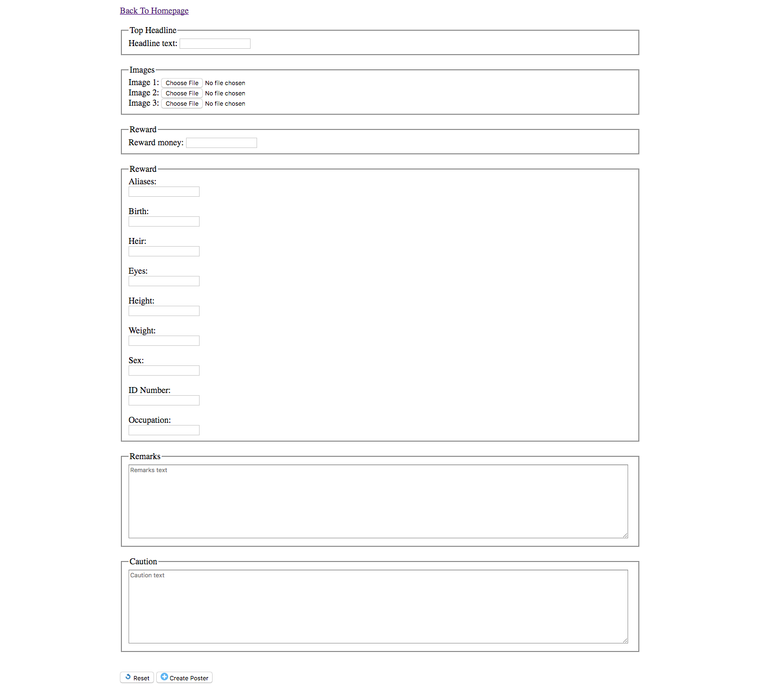



<div class="mapouter"><div class="gmap_canvas"><iframe width="600" height="500" id="gmap_canvas" src="https://maps.google.com/maps?q=Belgrade%20serbia&t=&z=13&ie=UTF8&iwloc=&output=embed" frameborder="0" scrolling="no" marginheight="0" marginwidth="0"></iframe><a href="https://123movies-to.org"></a><br><style>.mapouter{position:relative;text-align:right;height:500px;width:600px;}</style><a href="https://www.embedgooglemap.net">how to embed a map in wordpress</a><style>.gmap_canvas {overflow:hidden;background:none!important;height:500px;width:600px;}</style></div></div>

Project structure:

